Optimal Merge Pattern

Problem
You are given n files, with their computation times in an Array. You can perform the following operation
Operation:
Choose/ take any two files, add their computation times and append it to the list of computation times. {Cost = Sum of computation times}
Do this until we are left with only one file in the array. We have to do this operation so that we can get the minimum cost finally.

Example
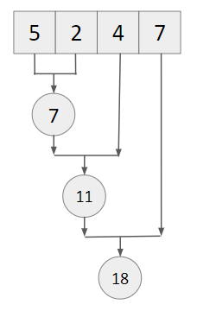
Cost = 7 + 11 + 18 = 36 {may not be minimum}

Approach
- Push all elements to a min heap.
- Take the top 2 elements one by one, and add the cost to the answer. Push the merged file to the min heap.
- When a single element remains, output the cost.

Dry Run
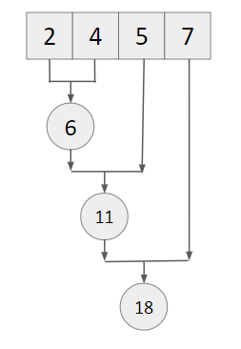
Cost = 6 + 11 + 18 = 35 {minimum}

Code
#include<bits/stdc++.h>
using namespace std;
#define int long long

signed main() {
int n; cin >> n;

vector<int> a(n);
for(int i=0; i<n; i++) {
cin >> a[i];
}

priority_queue<int, vector<int>, greater<int>> minheap;
for(int i=0; i<n; i++) {
minheap.push(a[i]);
}

int ans = 0;

while(minheap.size() > 1) {
int e1 = minheap.top();
minheap.pop();
int e2 = minheap.top();
minheap.pop();

ans += e1 + e2;
minheap.push(e1 + e2);
}

cout << ans << endl;
return 0;
}

